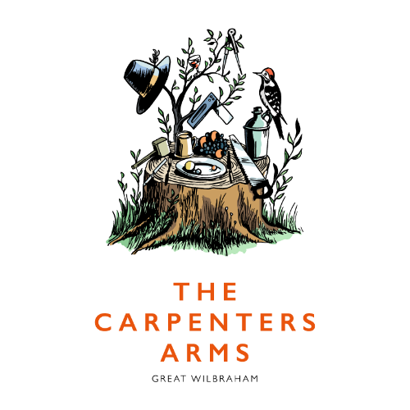

DOG MENU

We have a teamed up with our pal Denzel, to provide our favourite guests with healthy snacks!
Denzel’s treats are made from 100% natural ingredients, free from grain and hand baked in his UK bakery. All packaging is 100% plastic free! Take a look @denzelstory on Instagram.

TO CHEW
Denzel’s Soft Baked Chews (4 in a pack, under 50 calories each) £2.50
High Protein – Spinach, chickpea and chicken
Brunch – Avocado, eggs and salmon
Nut Butter – Peanut, cashew and turkey
Superfood – Banana, berries and salmon
Paleo – Orange, almonds and duck

To Nibble
Denzel’s Soft ‘n’ Squishy Treats (110 low calorie bites per pack) £2.90
High protein – Spinach, chickpea and chicken
Brunch – Avocado, eggs and salmon
Nut Butter – Peanut, cashew and turkey

From The Kitchen
A Cooked Sausage £2

To Drink
Posh Pooch Wine (0% Alcohol) £3
The Best Cambridgeshire Tap Water Free

